ASSIGNMENT 3: GIT & R
Name : Fatima Shaheen
Roll No : MSCS23019

Step 1: Load data.table
Step 2: Load or convert your film table into a data.table
Step 3: Write query to perform the assigned task(apply join if required)
Step 4: View result

Question 1) Write a query to display all films that have a rating of PG and a rental duration greater than 5 days.
Explanation
The query refines the film table to display solely those movies that have received a PG rating.
Additionally, it verifies that the rental duration (the number of days a film is available for rent) exceeds 5 days.
Only pertinent columns (film_id, title, rating, rental_duration) are shown.
As a result, we will obtain a list of all films rated PG that can be rented for a period longer than 5 days.

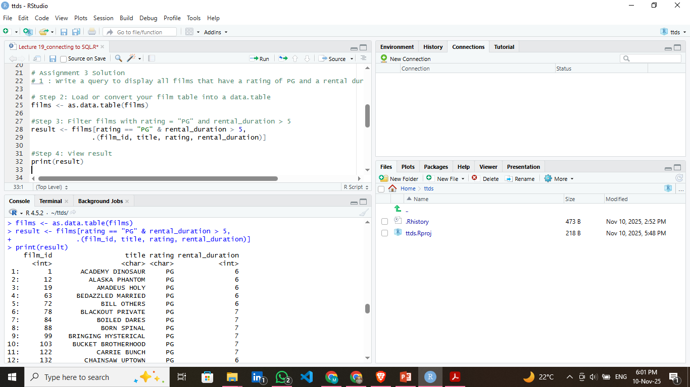

- Write a query to display the average rental rate of films, grouped by their rating.

Explanation
Organizes all films according to their ratings (G, PG, R, etc.).
Determines the average rental price for each category utilizing mean().
The na.rm = TRUE parameter eliminates any missing values.
Consequently, it indicates which categories of films tend to have a higher average rental cost.

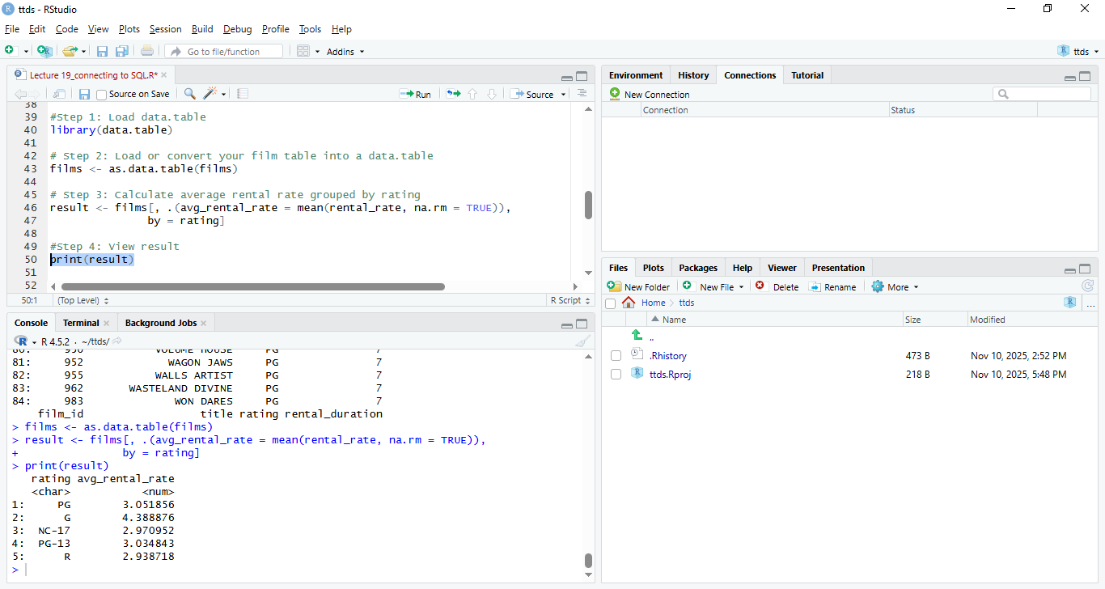

- Write a query to count the total number of films in each language.

Explanation
.N calculates the total number of films corresponding to each language_id.
Subsequently, the result is merged with the language table to present the language name in place of its ID.
Consequently, it displays the total number of films available in each language (e.g., English, French).

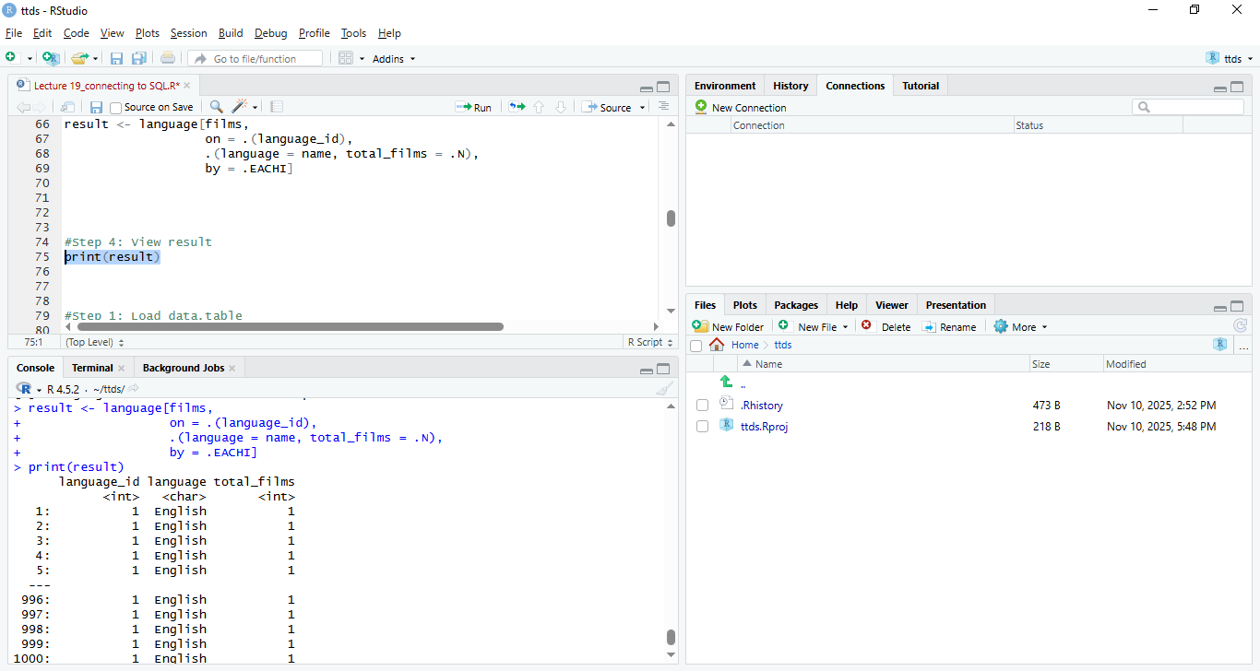

- List the customers’ names and the store they belong to.

Explanation
Joins several tables: customer → store → address → city.
Merges the first and last names to create customer_name.
Fetches the name of the city where the customer’s store is situated.
Consequently, it presents each customer’s name along with the city of their associated store.

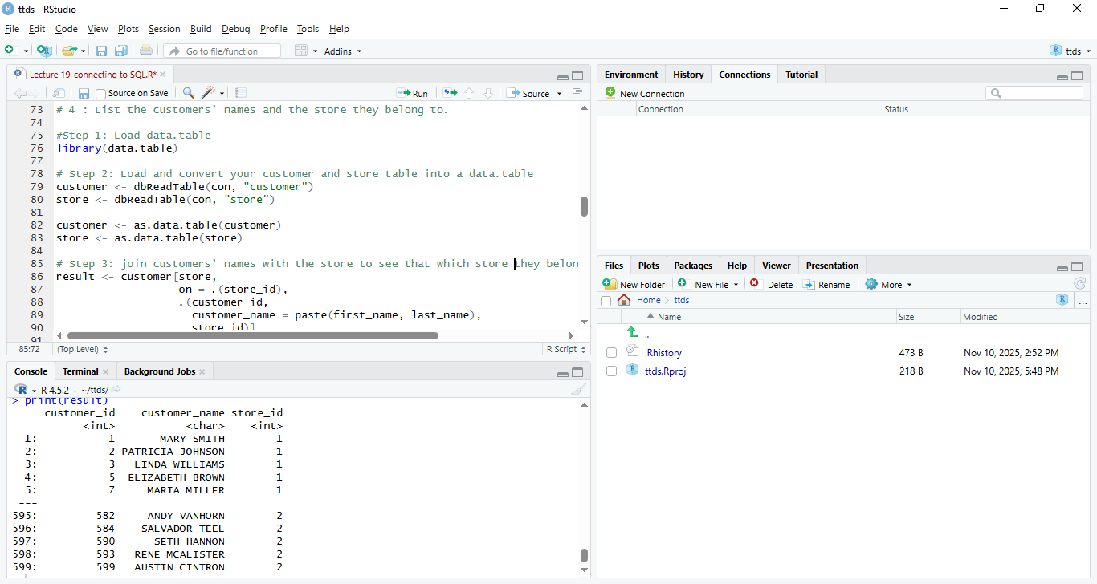

#optional: To show store address and location
Explanation

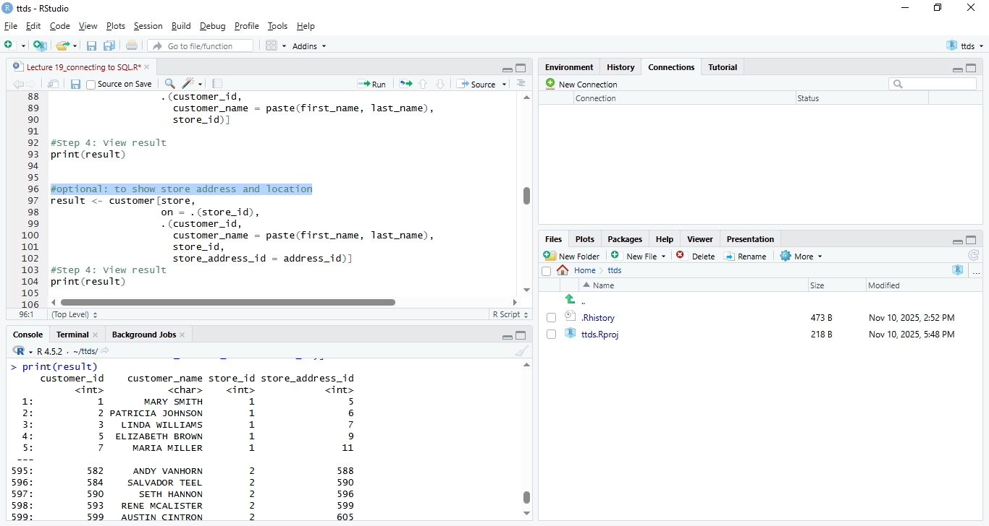

- Display the payment amount, payment date, and the staff member who processed each payment.

Explanation
Links the payment table to the staff table via staff_id.
Presents payment information (amount and date) along with the full name of the staff member.
Assists in identifying which employee managed each transaction.
As a result it displays all payments including the date, amount, and the staff member responsible.

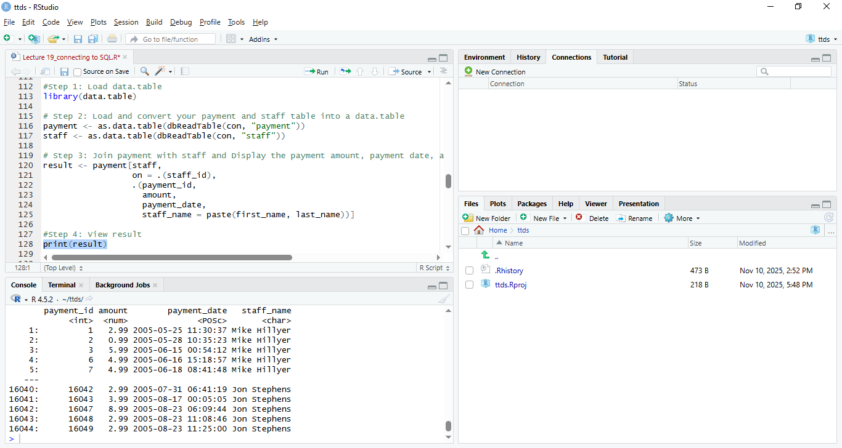

- Find the films that are not rented.

Explanation
Retrieves all inventory IDs that have been rented from the rental table.
Identifies which inventory items have never been rented.
Subsequently, it extracts the details of these films and counts them using unique N().
As a result, list of films that have never been rented along with a total count of unrented films.

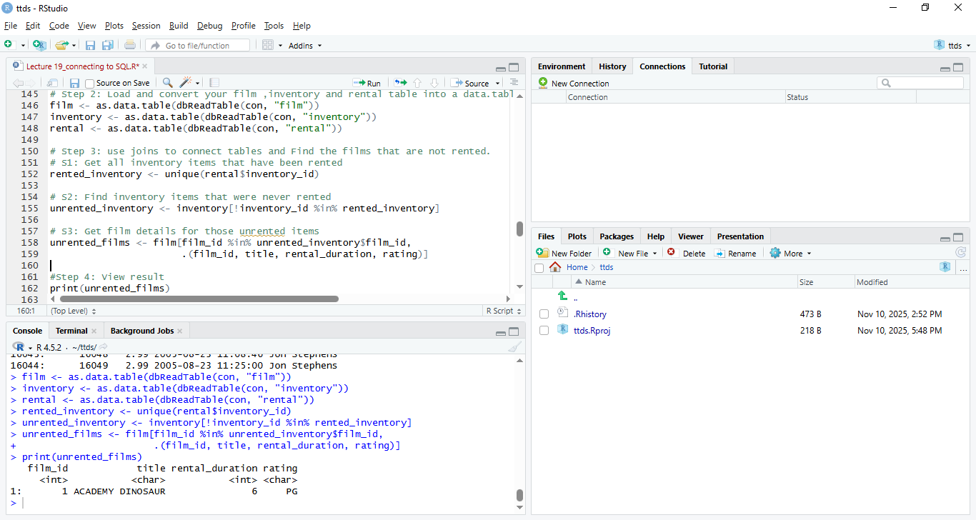

- Plot any graph of your choice.

Graph 1 :Average Rental Rate by Film Rating

Explanation
It computes the average rental cost associated with each film rating (such as G, PG, PG-13, R, etc.) and presents this information in the form of a bar graph.
This allows us to easily identify which categories of films tend to have higher or lower average prices.
For instance, movies rated PG-13 or R may exhibit marginally elevated rental prices compared to those rated G.

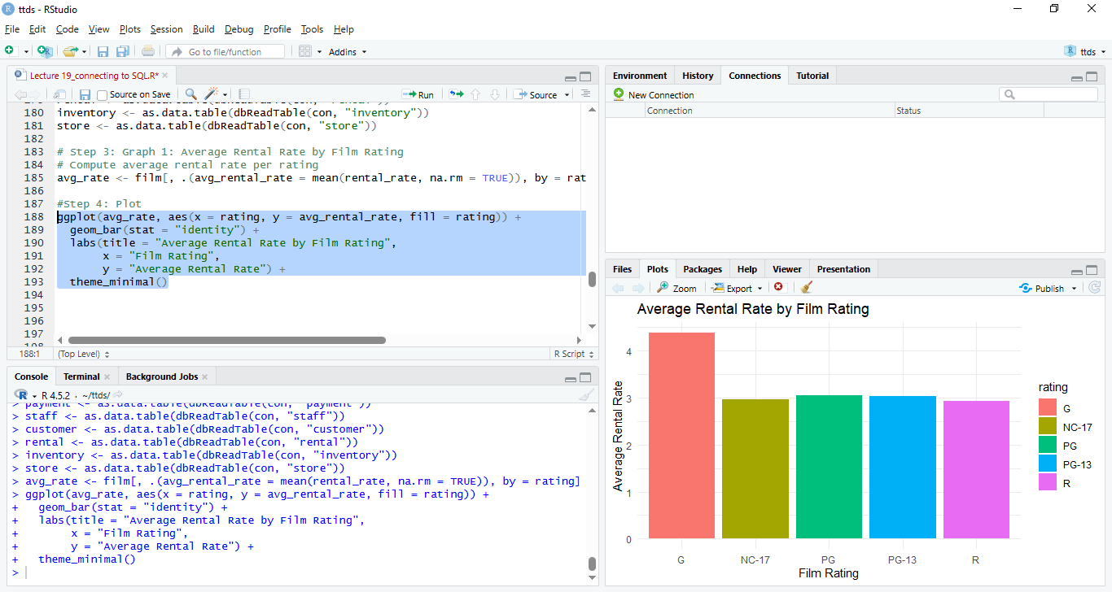

Graph 2 : Total Payment Amount Collected by Each Staff Member

Explanation

It aggregates all the payments managed by each staff member and displays the total through a bar graph.
This allows us to identify which staff member processed the highest number of payments or collected the most funds.

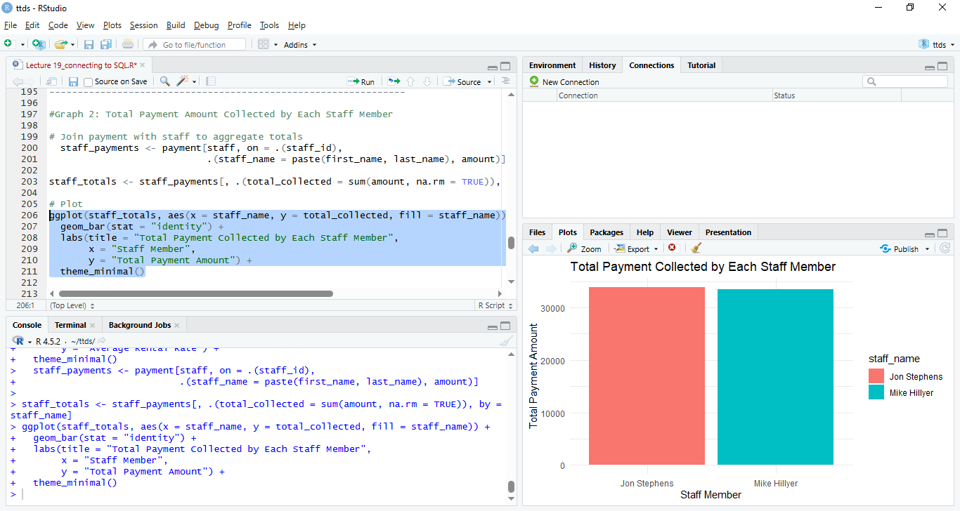

Graph 3 : Most Rented Films (Top 10)

Explanation
It calculates the number of rentals for each film and subsequently presents the top 10 films in a bar chart.
This illustrates that the most popular and frequently rented movies are displayed at the top.

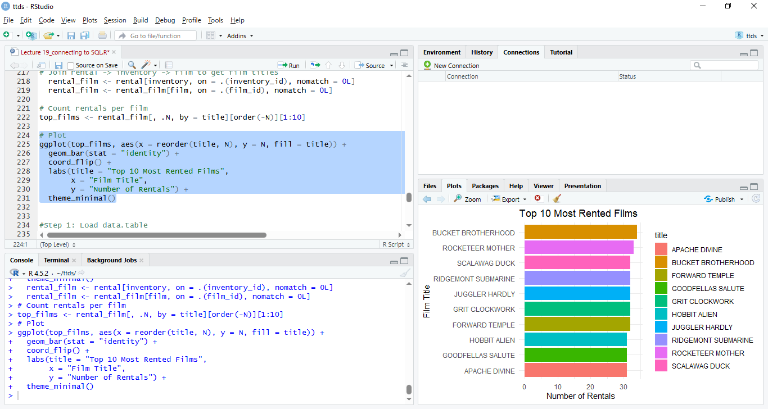
Step 4: Plot total rentals by city

Explanation

It counts the number of rentals that occurred in each city and presents the top 10 cities in a chart.
This allows us to identify which cities have the highest rental activity and where business is most robust.

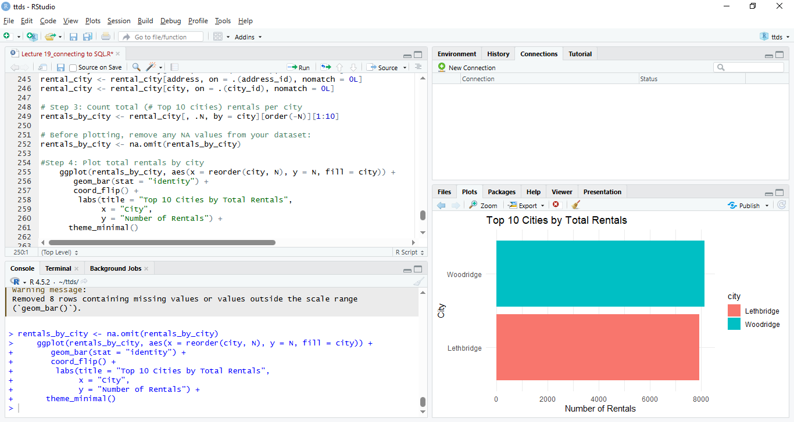

- Use of Git in the entire assignment.
Explanation

